Grade 7 Accelerated · Unit 4 · Lesson 1  Adding and Subtracting in Scientific Notation  Question Bank 4.01 ANSWER KEY | Name  Date  Period

Show your work. Circle your final answer.
For questions 1 through 6, add or subtract. Write each answer in scientific notation.
1. 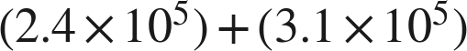


2.


3. 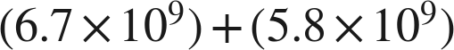
The sum of the coefficients is over 10, so the answer needs one more step.

4. 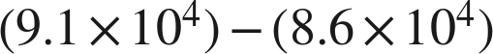

A coefficient below 1 is unfinished too: point one place right, exponent down one.

5. 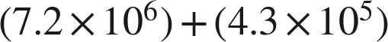

, and .

6.

. The exponents are two apart, the widest gap allowed.

Real quantities.
7. Neptune's diameter is about  kilometers. Saturn's is about 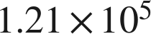 kilometers.
a. What is the sum of the two diameters?
 km
, so the sum is .
b. Jupiter's diameter is about 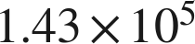 kilometers. Is your answer to part (a) greater than Jupiter's diameter?
Yes — .
Same power of ten, so the coefficients decide.

8. A city's population is about 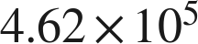. The surrounding county's population is about 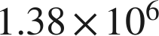.
a. What is the total population of the city and the county?
 people
.
b. How many more people live in the county than in the city?
 people
, and .

Working backwards.
9. Find the missing number in each equation.
a.
n = 6.5
.
b.
n = 5.5
c. 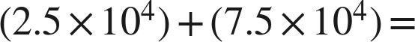 ______

The coefficients sum to exactly 10, so the answer is  — finished, that is .

Reading someone else's work.
10. Priya writes . Name the two mistakes she made, and give the correct sum.
She added the coefficients without first writing both numbers over the same power of ten, and she added the exponents. The correct sum is .
, and .

11. Which is the value of , written in scientific notation?
○ A. 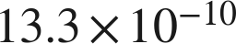
● B. 
○ C. 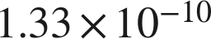
○ D. 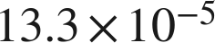
B

12. Select ALL of the expressions whose value is 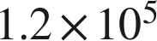.
☒ A. 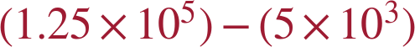
☐ B. 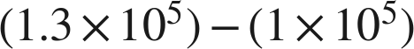
☒ C. 
☐ D. 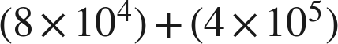
☒ E. 
☒ F. 
A, C, E and F
E gives , which is 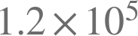 once it is finished.

